**COE 768: Mid-Term Test**

**2013**

* There are **Four** questions. Answer **ALL** of them. The points assigned to the questions are indicated at the beginning of the questions. The total points of this paper are 100.
* If doubt exists as to the interpretation of any question, the student is urged to submit with the answer paper, a clear statement of any assumption made.
* Time limit: 1 hours.

**Student Name:**

**Student ID:**

|  |  |
| --- | --- |
| **Question** | **Marks** |
| Question 1 (30%) |  |
| Question 2 (30%) |  |
| Question 3 (15%) |  |
| Question 4 (25%) |  |
| **Total**  **(100%)** |  |

**Problem 1 (30 points)**

Consider the connection between two stations as illustrated in the following figure. The protocol stack has four layers (without the network layer). The figure also shows the PDU formats of the transport and data-link layers.

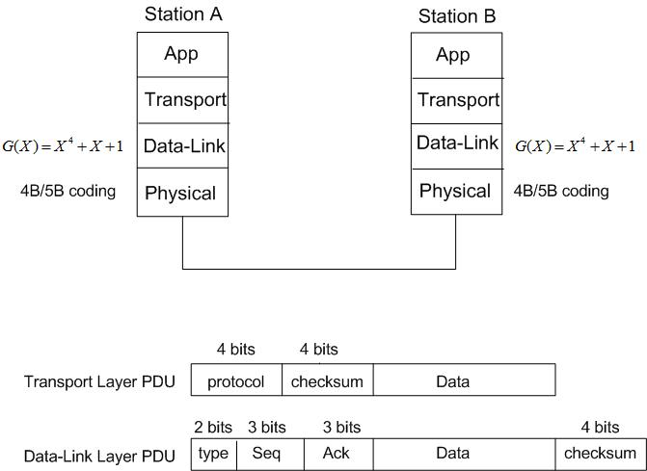

The transport and data-link layers use 1’s complement and CRC to compute their checksums, respectively. The generator polynomial for the CRC is G(x) = x4+x+1. Finally, the data-link PDU is encoded by 4B/5B coding.

Suppose the application in station A sends a byte with the value of 10010011 to the application in station B.

1. Determine the corresponding contents of the transport layer PDU and Data-link Layer PDU.
2. Determine the corresponding bit stream (not the waveform!) generated by the 4B/5B encoding.

Use the following parameters in your answers:

* The value of the protocol field in the transport layer PDU in this case is 1010
* The value of the type field in the data-link layer PDU is 00;
* The sending and receiving windows’ parameters in Station A: Sn=Sf=4 and Rn=1

**Bonus question (5 points):** What is the use of the protocol field in the Transport layer PDU?

**Problem 2 (30 points)**

Computer A is communicating with Computer B over a physical link using HDLC protocol which has the following parameters:

* 3-bit sequence field and 3-bit acknowledgement (next) field;
* Selective-Repeat is adopted as the sliding window mechanism (**Note:** the sending window size is therefore 4).

The sending and the receiving windows of Computer A have the following values:

$S_{f}=7; S_{n}=2;R_{n}=5$

Consider the following sequence of events:

1. At t=0, Computer A wants to send four data frames to Computer B. Each frame takes 1 msec to transmit.
2. At t=2.5 msec, Computer A receives a data frame from Computer B with seq=6 and next=0.
3. At t=5 msec, Computer A receives the second data frame with seq=4 and next=0.
4. At t=7 msec, Computer A receives the third data frame with seq=5 and next=4.

Based on the above sequence of events, answer the following questions:

1. How would Computer A deal with the data frame received at 2.5 msec (event 2)?
2. How would Computer A deal with the second data frame received at t=5 msec (event 3)?
3. How would Computer A deal with the third data frame received at t=7sec (event 4)?
4. At what time (approximately) would Computer A complete the transmission of all four frames? Give the values of the sequence fields and next fields of these four frames.

**Problem 3 (15 points)**

Consider the following two communication systems:

System 1:

Link distance = 10 km;

Channel data rate = 1 Mbps;

Frame size = 500 bytes.

Bit-Error-Rate is low

System 2:

Link distance = 1000 km;

Channel data rate = 10 Mbps;

Frame size = 500 bytes.

Bit-Error-Rate is low

Select the Error control protocol (Stop-and-Wait, Go-Back-n or Selective Repeat) for each system. In each case, specify the minimum sending window size and number of bits required for the sequence number field in data frames. You **must provide enough justifications** to support your selections.

**Problem 4 (25 points)**

1. Consider an application uses TCP as the transport layer protocol. If the application at the sending side makes two “write” system calls to send 4000 bytes of data to the receiving application:

for (n=0; n<2; n++)

write(s, buffer, 2000);

In theory, how many “read” system calls the receiving application should make to receive all 4000 bytes of data? Provide detailed explanation.

1. In lab 4, the server notifies the client of the completion of file transfer by terminating the TCP connection. An alternative approach is that after sending all the data in the file, the server sends a special character with value of 0xFF. The reception of this special character by the client indicates to the client that the file transfer is completed.

Modify your lab 4 client program to implement the alternative approach suggested above **You do not need to implement the server program** **and** **only need to show the portions of the client program that is modified.**

1. The approach suggested in part (b) only works for ASCII (Text) files. It will not work for binary files (e.g. video/audio files). Suggest a modification that makes the above approach work for binary files too. **Do not write the program!**